8-BIT DIVISION

EXP NO: 4

AIM:
To write an assembly language program to
implement 8-bit division using 8085 processor.

ALGORITHM:

1) Start
the program by loading a register pair with the address of memory location.

2) Move
the data to a register.

3) Get
the second data and load it into the accumulator.

4) Subtract
the two register contents.

5) Increment
the value of the carry.

6) Check
whether the repeated subtraction is over.

7) Store
the value of quotient and the reminder in the memory location.

8) Halt.

PROGRAM:

LDA 8501

MOV B, A

LDA 8500

MVI C,00

LOOP: CMP B

JC LOOP1

SUB B

INR C

JMP LOOP

LOOP1: STA 8502

MOV A, C

STA 8503
INPUT:
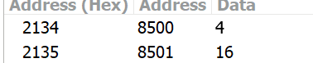

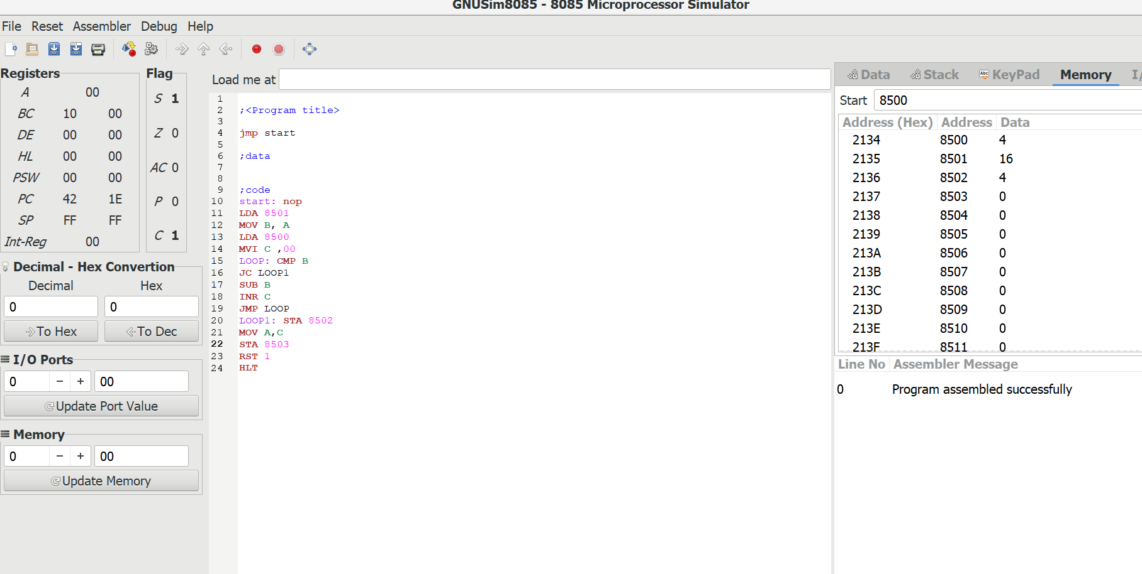

OUTPUT:
